Chapter 3

METHODOLOGY
This chapter details the development and testing of an automated device designed to accelerate liquid organic fertilizer production. It outlines the design, fabrication, and evaluation processes used to build the prototype, integrate its hardware and software, and implement machine learning for optimized juice extraction and fermentation.

PROJECT DESIGN
Research Design
This study utilizes a developmental and experimental research design to create, build, and test a functional prototype. The developmental aspect focuses on producing the physical device and evaluating its hardware, software, and machine learning performance.
The experimental component directly compares this automated system against traditional, manual fermentation methods. The project tests how effectively the device processes fruit and plant materials into liquid organic fertilizer by measuring key outcomes, specifically pH levels, volume yields, and overall fermentation time.

Prototype Design
The proposed prototype is a compact, multi-stage automated device designed to perform the following sequential operations:
- The system automatically weighs the extracted organic material and releases the exact amount of molasses needed to start fermentation, using a 1:1 ratio for FFJ and a 1:0.5 ratio for FPJ.
- A motor controlled by a dual relay automatically stirs the mixture to ensure everything is evenly distributed.
- Fermentation takes place inside a plastic chamber where sensors connected to an ESP32 and Raspberry Pi 5 constantly track the pH, temperature, humidity, CO₂ gas levels, and time.
- After fermentation, the mixture passes through a filtering system to separate the final liquid organic fertilizer from the solid waste.

The prototype is built into a strong metal frame with wheels for easy transport and rubber mounts to reduce vibration. It runs on a 12V power supply with a buck converter to safely drop the voltage for the low-power electronics.

System Architecture / Block Diagram

Schematic/Circuit Diagram
Wiring Diagram
The Proposed Prototype

Hardware and Software Specifications
1. Hardware Components
Hardware Components Specification
Category | Component | Specification | Description
Micro- controllers | Raspberry Pi 5 | Processor: Broadcom BCM2712  CPU: Quad-core Cortex-A76 @ 2.4 GHz  RAM: 4GB / 8GB LPDDR4X  USB: 2x USB 3.0, 2x USB 2.0  Connectivity: Wi-Fi, Bluetooth 5.0  OS: Raspberry Pi OS (Linux) | Main processing unit responsible for running machine learning models (Isolation Forest and Random Forest), data logging to InfluxDB, and orchestrating all sensor data pipelines.
 | ESP32 DevKit V1 | Processor: Xtensa LX6 Dual-Core @ 240 MHz  Flash: 4MB  RAM: 520KB SRAM  Wi-Fi: 802.11 b/g/n (2.4 GHz)  Bluetooth: BLE 4.2  GPIO: 30 pins | Central embedded controller for real-time sensor acquisition and actuator control. Enables wireless IoT monitoring and communicates with the Raspberry Pi 5 via UART/Wi-Fi.
Sensors | pH Sensor  (DFRobot SEN0161) | Range: 0–14 pH  Accuracy: ±0.1 pH  Operating Voltage: 5V DC  Output: Analog voltage | Monitors the acidity of the fermentation solution. A drop in pH indicates active microbial fermentation and is a key classification parameter for the Random Forest model.
 | Gas Sensor  (MQ-135) | Target Gas: CO₂, NH₃, Benzene  Operating Voltage: 5V DC  Output: Analog + Digital  Preheat Time: ~20 seconds | Detects CO₂ and other fermentation gases inside the chamber. Elevated gas concentration signals active microbial activity and is used for anomaly detection.
 | Temperature &  Humidity Sensor (DHT11) | Temp Range: 0–50°C (±2°C accuracy)  Humidity Range: 20–90% RH (±5%)  Operating Voltage: 3.3–5V DC  Output: Single-wire digital | Measures ambient temperature and humidity around the fermentation chamber. Environmental conditions affect microbial stability and overall fermentation rate.
 | Waterproof Temp.  Sensor (DS18B20) | Range: -55°C to +125°C  Accuracy: ±0.5°C (−10 to +85°C)  Operating Voltage: 3.0–5.5V DC  Protocol: 1-Wire digital | Measures temperature directly inside the fermentation liquid. Waterproof design ensures safe submersion; optimal fermentation occurs at 30–35°C.
 | Load Cell +  HX711 Module | Load Cell Capacity: 5 kg max  HX711 Resolution: 24-bit ADC  Operating Voltage: 2.6–5.5V DC  Output: Serial digital (SPI-like) | Measures the weight of raw organic materials to ensure correct ingredient ratios (molasses:organics = 1:1 for FFJ, 1:0.5 for FPJ). System input is limited to 5 kg maximum.
 | Temp. & Humidity  Sensor (DHT22) | Temp Range: -40–80°C (±0.5°C accuracy)  Humidity Range: 0–100% RH (±2–5%)  Operating Voltage: 3.3–5V DC  Output: Single-wire digital | Higher-precision ambient sensor used as supplemental monitoring. Provides more accurate environmental data compared to DHT11, especially in fluctuating conditions.
 | Turbidity Sensor  (SEN0189) – Optional | Operating Voltage: 5V DC  Output: Analog (0–4.5V)  Measurement: NTU units  Interface: Analog pin | Monitors liquid clarity to track the breakdown of organic solids during fermentation. Used optionally for extended quality analysis and output verification.
Timing Module | RTC Module  (DS3231) | Accuracy: ±2 ppm (0–40°C)  Operating Voltage: 2.3–5.5V DC  Interface: I2C  Battery Backup: CR2032 | Provides accurate timestamps for all sensor readings and fermentation events. Essential for time-based process monitoring and ML training dataset labeling.
Extraction System | Industrial Electric  Grinder / Shredder | Material: Stainless steel blades  Drive: DC Motor (12–24V)  Capacity: Up to 5 kg input  Operation: Automated via relay | Crushes and finely chops raw fruits and vegetables before extraction, increasing surface area for faster sugar release and accelerating microbial fermentation activity.
 | Screw Press /  Hydraulic Press | Type: Food-grade manual or motorized  Function: Cold-press juice extraction  Output: Liquid juice from crushed material | Extracts juice from crushed organic materials after grinding. Maximizes liquid yield and ensures a consistent volume of fermentation input per batch.
 | DC Gear Motor  (12V–24V) | Voltage: 12–24V DC  Type: High-torque DC gear motor  Function: Drives grinder/press | Provides sufficient torque for continuous mechanical processing of organic waste materials, driving the grinder or press mechanism.
 | Motor Driver  (BTS7960) | Operating Voltage: 6–27V  Max Current: 43A  PWM Frequency: Up to 25 kHz  Control Interface: Digital GPIO | Controls motor speed and direction for the grinder system. Supports high-current loads and enables automated, programmable mechanical operation via the ESP32.
Fermentation Chamber | Food-Grade  Fermentation Tank | Material: Food-grade plastic (BPA-free)  Capacity: Suitable for 1–5 kg input  Feature: Slightly open / vented design | Houses the fermentation mixture throughout the entire process. Food-grade material ensures a contamination-free environment safe for organic fertilizer production.
 | Airtight Lid with  Airlock Valve | Type: One-way CO₂ airlock  Seal: Rubber-gasketed lid  Function: CO₂ release, O₂ block | Allows CO₂ produced by microbial activity to escape while preventing oxygen from entering, maintaining the anaerobic conditions required for fermentation.
 | Motorized Stirrer  (MIX-4045 + Motor) | Controller: MIX-4045 Dual Relay Module  Drive: 12V DC motor  Operation: Interval-based automation  Function: Mixture agitation | Mixes the fermentation solution at defined intervals to ensure uniform microbial distribution and consistent reaction speed throughout the fermentation chamber.
Temperature Control | Wi-Fi Temperature  Controller (ITC-308) | Temp Range: -50°C to +99°C  Control Mode: Dual relay (heat/cool)  Connectivity: Wi-Fi enabled  Accuracy: ±1°C | Automatically regulates the heating pad and cooling fan to maintain the optimal fermentation temperature of 30–35°C. Wi-Fi enabled for remote monitoring and adjustment.
 | Silicone Heating Pad  (12V) | Voltage: 12V DC  Type: Flexible silicone pad  Control: Relay-switched via ITC-308 | Raises chamber temperature when it falls below the set threshold. Flexible design allows direct contact with the fermentation tank for efficient heat transfer.
 | Cooling Fan (12V) | Voltage: 12V DC  Type: DC brushless fan  Control: Relay-switched via ITC-308 | Dissipates excess heat from the fermentation chamber. Works in tandem with the heating pad to maintain precise temperature regulation and prevent microbial die-off.
Liquid Control & Fluid System | Peristaltic Pump  (12V) | Voltage: 12V DC  Flow Rate: Adjustable  Type: Peristaltic (no contamination) | Adds molasses or microbial solution to the fermentation chamber in precise, controlled quantities without risk of backflow or cross-contamination.
 | Solenoid Valve  (12V) | Voltage: 12V DC  Type: Normally-closed solenoid  Control: Relay-switched via ESP32 | Controls automated liquid input and output flow within the system, enabling programmatic liquid movement without the need for manual intervention.
 | Food-Grade  Silicone Tubing | Material: Food-safe silicone  Compatibility: Acid-resistant  Use: Liquid transfer between stages | Safely transfers liquids between system components. Silicone construction prevents chemical leaching and is compatible with the acidic pH of organic fermentation solutions.
Power Supply | SMPS Power Supply  (12V) | Output: 12V DC  Type: Switching Mode Power Supply  Requirement: Continuous AC supply | Main power source for all system components. Provides stable regulated 12V DC; continuous supply is required to prevent data logging interruptions during operation.
 | Buck Converter  (LM2596) | Input: Up to 40V DC  Output: Adjustable 1.23–37V (set to 5V/3.3V)  Max Current: 3A  Type: Step-down DC-DC converter | Steps down 12V to 5V or 3.3V to safely power low-voltage components including the ESP32, sensors, and modules, protecting them from overvoltage damage.
Monitoring & IoT | 16×2 LCD with  I2C Module | Display: 16 characters × 2 lines  Interface: I2C (SDA/SCL)  Operating Voltage: 5V DC  Backlight: LED | Displays real-time sensor readings on the device itself. Allows on-site monitoring of pH, temperature, and gas levels without requiring a smartphone or internet connection.
 | Blynk IoT Platform | Type: Cloud IoT dashboard  Connectivity: Wi-Fi (via ESP32)  Features: Real-time graphs, alerts, controls  Access: Smartphone app | Enables remote monitoring and control of the fermentation system via a smartphone application, providing real-time data access and alert notifications from any location.
 | SD Card Module | Interface: SPI  Compatibility: MicroSD cards  Operating Voltage: 3.3V / 5V DC  Function: Local data logging | Stores timestamped fermentation data locally for offline access. Serves as a backup logging mechanism and as a data source for ML model training and performance evaluation.
 | InfluxDB  (on Raspberry Pi 5) | Type: Time-series database  Host: Raspberry Pi 5 (local server)  Query Language: InfluxQL / Flux  Integration: Python ML pipeline | Structured database optimized for high-frequency sensor data storage. Integrates directly with the machine learning pipeline for anomaly detection and stage classification.
Structural & Mechanical | Steel / Aluminum  Frame | Material: Steel or Aluminum  Function: Full system support structure  Finish: Powder-coated or bare metal | Supports the entire device and all mounted components. Provides mechanical stability and structural durability required for continuous operation in a farm environment.
 | Rubber Vibration  Mounts | Type: Anti-vibration rubber grommets  Function: Vibration dampening  Placement: Under grinder and motor mounts | Dampens vibrations produced by the grinder and motor, preventing mechanical interference with sensor readings and ensuring fermentation stability throughout operation.
 | Caster Wheels | Type: Heavy-duty swivel casters  Load Capacity: Suitable for full prototype  Function: Prototype mobility | Provides mobility to the complete prototype system, allowing easy transport and repositioning for deployment across different farm environments or testing locations.

2. Software Applications
Software Components Specification
Category | Component | Specification | Description
Development Environment | Arduino IDE | - Developer: Arduino / Espressif  - Type: Integrated Development Environment  - Language: C / C++  - Platform: Windows, macOS, Linux  - Function: Writing and uploading firmware to the ESP32 DevKit V1  - Features: Serial monitor, library manager, board support packages | Used to write, compile, and upload embedded firmware to the ESP32 microcontroller. Manages sensor polling, actuator control, and serial/Wi-Fi communication logic.
 | Thonny /  VS Code | - Developer: University of Tartu / Microsoft  - Type: Python IDE / Source-code Editor  - Platform: Windows, macOS, Linux  - Function: Python scripting and ML development on Raspberry Pi 5  - Features: Syntax highlighting, debugging, extensions, Git integration | Primary code editor for developing Python scripts on the Raspberry Pi 5, including ML model training, sensor data processing, and InfluxDB integration.
Programming Language | Python 3 | - Developer: Python Software Foundation  - Version: Python 3.x  - Platform: Raspberry Pi 5 (Linux)  - Function: ML model execution, data processing, sensor orchestration  - Key Libraries: scikit-learn, pandas, NumPy, matplotlib, influxdb-client | Primary programming language for the Raspberry Pi 5. Used to implement machine learning models, process time-series sensor data, and manage InfluxDB logging and Blynk communication.
 | C / C++  (Arduino Framework) | - Framework: Arduino Core for ESP32  - Platform: ESP32 DevKit V1  - Function: Real-time embedded firmware for sensor reading and actuator control  - Libraries: DHT, HX711, SEN0161 pH, MQ135, PubSubClient (MQTT) | Used to program the ESP32 microcontroller for real-time sensor acquisition, relay switching, motor control, and Wi-Fi-based communication with the Raspberry Pi 5.
Machine Learning | Isolation  Forest  (scikit-learn) | - Developer: scikit-learn / Python  - Type: Unsupervised Anomaly Detection Algorithm  - Language: Python  - Input: Real-time sensor readings (pH, temp, CO₂, weight)  - Function: Flags abnormal fermentation readings as anomalies  - Features: No labeled data required, efficient for high-dimensional data | Detects abnormal patterns in sensor readings during fermentation. Flags data points as 'normal' or 'abnormal' in real time, triggering alerts when anomalies are detected.
 | Random  Forest  (scikit-learn) | - Developer: scikit-learn / Python  - Type: Supervised Classification Algorithm  - Language: Python  - Input: Labeled sensor readings (pH, temp, CO₂, timestamp)  - Function: Classifies fermentation stage (Early / Active / Near-ready / Ready)  - Features: Ensemble method, robust to noise, high accuracy | Classifies the current fermentation stage using labeled training data. Outputs one of four stage labels — Early, Active, Near-ready, or Ready — to guide system automation and user alerts.
Database | InfluxDB | - Developer: InfluxData  - Type: Time-Series Database  - Host: Raspberry Pi 5 (local server)  - Query Language: InfluxQL / Flux  - Function: Stores all timestamped sensor readings and fermentation logs  - Features: High-frequency write support, Python client library, Grafana integration | Stores structured time-series sensor data from all fermentation sessions. Serves as the primary data source for ML model training, performance evaluation, and historical trend analysis.
IoT Platform | Blynk IoT | - Developer: Blynk Inc.  - Type: Cloud IoT Dashboard and Mobile App  - Connectivity: Wi-Fi via ESP32  - Platform: iOS / Android smartphone app  - Function: Remote real-time monitoring and control of fermentation system  - Features: Live sensor graphs, push notifications, virtual pin control | Provides a mobile interface for remote monitoring of pH, temperature, CO₂, and fermentation stage. Sends real-time alerts to the user and allows manual override of actuators via smartphone.
Data Processing Libraries | pandas | - Developer: NumFOCUS / open-source  - Type: Python Data Analysis Library  - Language: Python  - Function: Sensor data manipulation, cleaning, and normalization  - Features: DataFrame operations, CSV import/export, time-series indexing | Used for preprocessing raw sensor data retrieved from InfluxDB. Handles normalization, removal of outliers, handling of missing values, and preparation of training datasets for ML models.
 | NumPy | - Developer: NumFOCUS / open-source  - Type: Numerical Computing Library  - Language: Python  - Function: Array operations and numerical computations for ML pipeline  - Features: N-dimensional arrays, linear algebra, random sampling | Provides foundational numerical array operations used by scikit-learn, pandas, and custom preprocessing scripts throughout the machine learning pipeline.
 | Matplotlib | - Developer: Matplotlib Development Team  - Type: Data Visualization Library  - Language: Python  - Function: Plots sensor trends, fermentation stage timelines, and ML outputs  - Features: Line charts, scatter plots, confusion matrices, exportable figures | Generates visual charts and graphs of fermentation sensor data and ML model outputs. Used for performance evaluation, research documentation, and result presentation.
Communi- cation Protocol | HTTP / REST  API | - Type: Application-layer Communication Protocol  - Implementation: ESP32 HTTP client → Raspberry Pi 5 Flask server  - Function: Transfers sensor data from ESP32 to Raspberry Pi 5 over Wi-Fi  - Features: Lightweight, widely supported, JSON payload format | Facilitates wireless communication between the ESP32 and the Raspberry Pi 5. Sensor readings are sent as JSON via HTTP POST requests, enabling real-time data relay to InfluxDB and the ML pipeline.

Software Tools and Platforms
System Flowchart and Algorithm

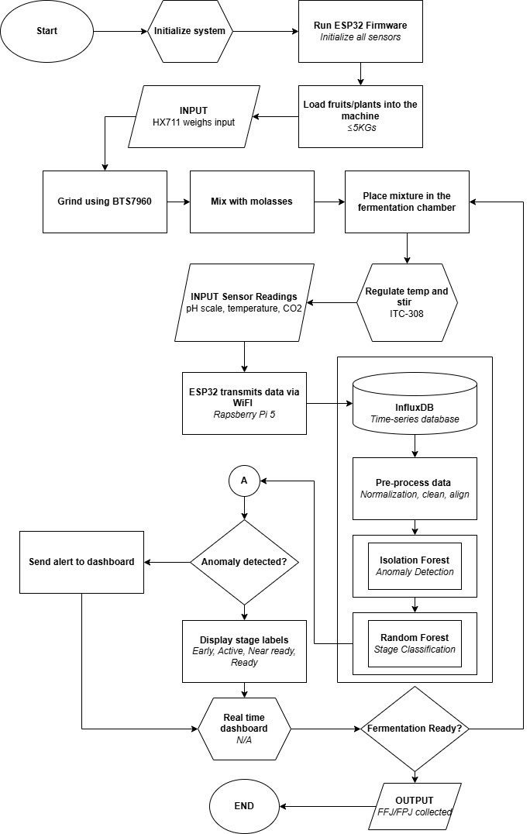
PROJECT DEVELOPMENT
Prototype Development Procedure
Hardware and Software Integration Diagram
Data Collection and Model Training

OPERATION AND TESTING PROCEDURE
System Operation Procedure
Testing Environment and Setup
EVALUATION
Evaluation Criteria
Evaluation Instrument
Statistical Treatment and Interpretation of Data

